
The global challenges
In 2050 there will be about 9.3 billion people sharing the same planet. Already today the world is facing intertwined challenges of food, water and energy security, as well climate change and desertification. Neither of these challenges is without solutions. At the same time it is clear that we cannot afford a response to one challenge that comes at the expense of another. The greatest challenges of our time are closely interlinked – the same must be true for the answers.

Food scarcity
Today, more than 800 million people are “food insecure”, meaning that they either starve or do not know where their next meal will come from.This situation brings with it large social and economic consequences. Toward 2050, rising population and incomes are expected to call for 70 percent more food production globally, and up to 100 percent more in developing countries, relative to 2009 levels. Experts agree that it is possible to achieve the increases in food production necessary to feed a population of 9.3 billion in 2050, but only if sufficient and timely investments are undertaken and policies to increase agricultural production are put in place.

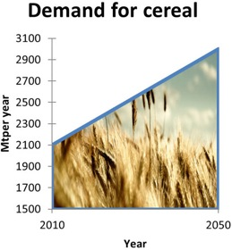
Gross investment requirements between 2007 and 2050 for irrigation development and management are estimated at almost US$1 trillion. Moreover land protection and development, soil conservation and flood control will require around US$160 billion, according to The Food and Agriculture Organization of the United Nations.

Energy consumption
The IEA’s Energy Technology Perspectives 2010 presents a baseline scenario assuming no new energy and climate policies. The scenario predicts that primary energy use will rise by 84% – and energy-related CO2 emissions roughly double – by 2050. In the face of climate science, such numbers leave little room for doubt that a low carbon/renewable energy revolution is necessary.

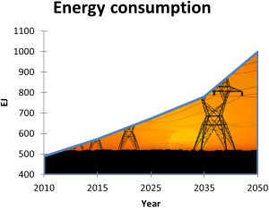
This revolution has the potential to bring about substantial benefits not just for the climate, but also in enhanced energy security and accelerated economic development.

Water scarcity
Water scarcity already affects a large portion of the global population. And the situation is not expected to improve any time soon: according to UNEP water use for crop irrigation must double by 2050 to meet the Millennium Development Goal on hunger.

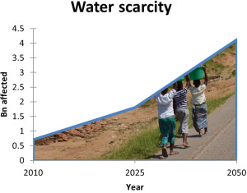
Imbalances between availability and demand, degradation of ground- and surface water quality, as well as escalating regional and international competition for water resources are among the key issues that must be addressed.

Climate change
The atmospheric concentration of CO2 passed 391,5ppm in 20116. This is higher than it has ever been in the last 650,000 years. The IPCC had earlier advised that it would be necessary to achieve at least a 50 % reduction in global CO2 emissions by 2050, compared to 2000 levels.

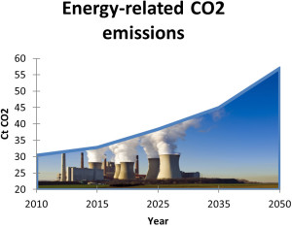
Leading experts are now warning that even this target may prove inadequate to prevent serious consequences of global warming.

Desertification
The livelihoods of more than one billion people in some 100 countries are threatened by desertification. It is estimated that desertification and land degradation represent an income loss of US$42 billion per year. Further, the barren lands lost annually could have provided 20 million tons of grain.

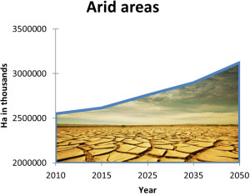
Even though desertification is most often directly triggered by localized drought, human activities are almost always a key underlying cause. It is therefore of major importance to introduce sustainable cultivation and irrigation practices, and to implement programs to prevent over-grazing and unsustainable outtake of biomass.

